JAYPEE UNIVERSITY OF ENGINEERING AND TECHNOLOGY

NAME-MAULSHREE SAXENA
ENROLLMENT- 151321
BATCH- B4
PHONE NO-7240915259

PROJECT- RESTAURANT MANAGEMENT SYSTEM
TITLE- HOTEL LEMON TREE

ABOUT-
THE PROJECT IS ABOUT A RESTAURANT MANAGEMENT SYSTEM. HOW A RESTAURANT MENU WILL LOOK IF WE ORDER SOMETHING ONLINE OR WITH GADGETS.
THIS PROJECT SIMPLIFIES THE MAN WORK BY AUTOMATICALLY REGISTERING THE MENU AND CALCULATING THE BILL FOR THE USER.

HOW TO USE-

WHEN WE START THE PROJECT, THIS MENU WILL APPEAR , SO THAT THE USER CAN EASILY OPERATE THE APP.
TO ENTER THE MENU, THE USER HAS TO CLICK THE 'ENTER' BUTTON. TO KNOW MORE ABOUT THE DESIGNER OF PROJECT, THE USER HAS TO CLICK 'ABOUT US'. TO EXIT THE PROJECT THE USER HAS TO CLICK 'EXIT'.

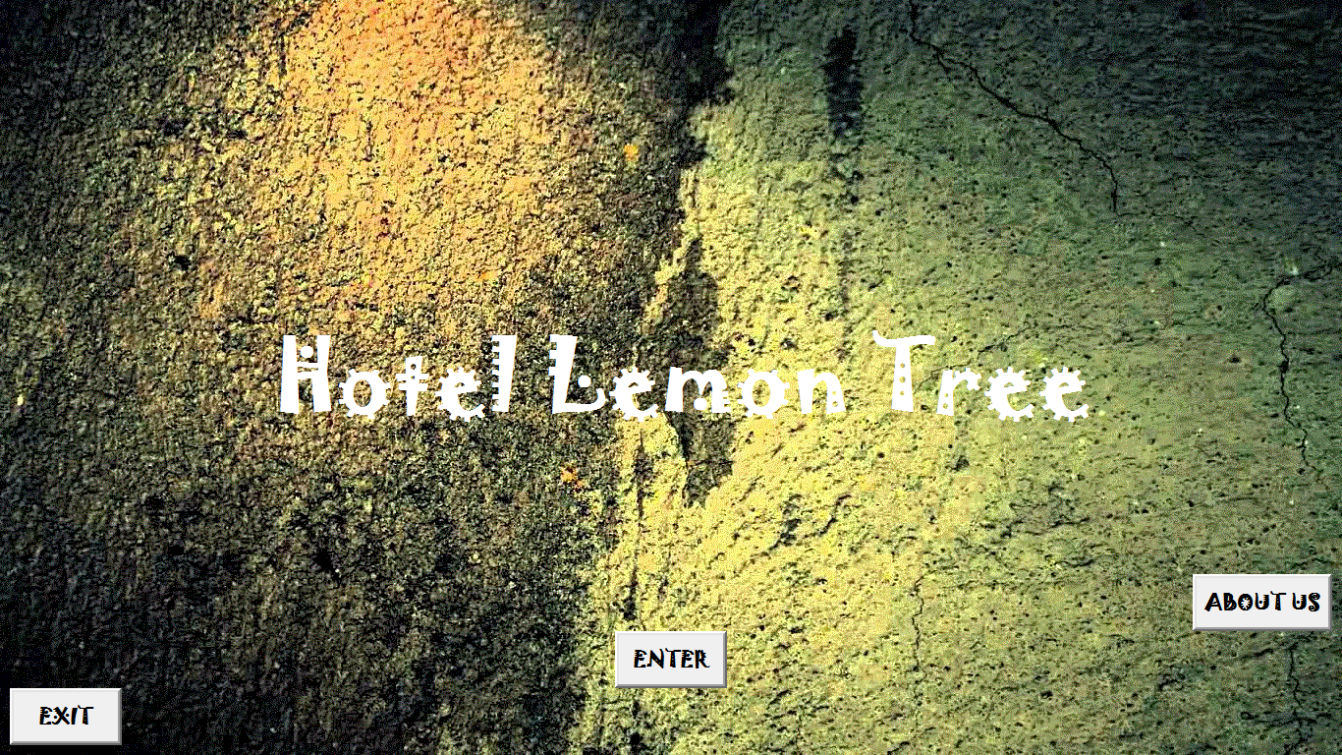

WHEN THE USER CLICKS ENTER BUTTON

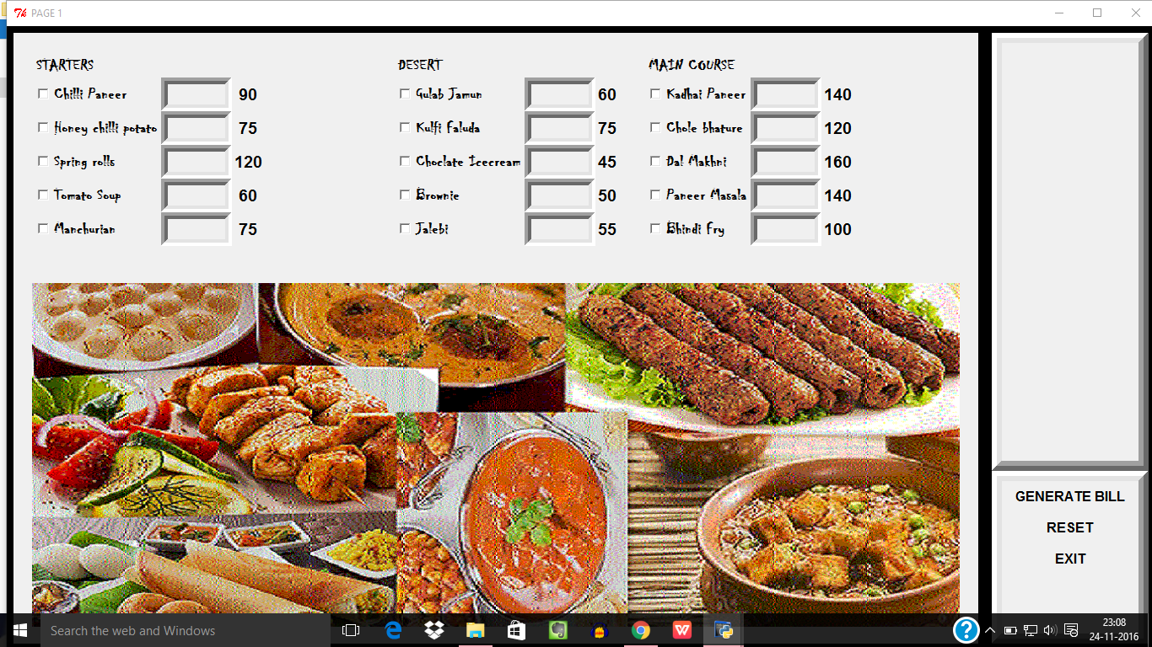
THIS MENU WILL APPEAR SO THAT THE USER CAN EASILY DECIDE THE MENU. WITH THE HELP OF GUI , THE PROJECT IS MORE UNDERSTANDABLE TO THE USER.

WHEN THE USER HAS TO ORDER SOMETHING, HE/SHE JUST HAVE TO TICK THE CHECK BUTTONS AND WRITE QUANTITY IN THE SPACE PROVIDED BESIDE THE NAME.
THEN THE USER HAS TO CLICK ON THE 'GENERATE BILL' BUTTON SO HE/SHE CAN KOW HIS CURRENT STATUS OF HIS BILL.

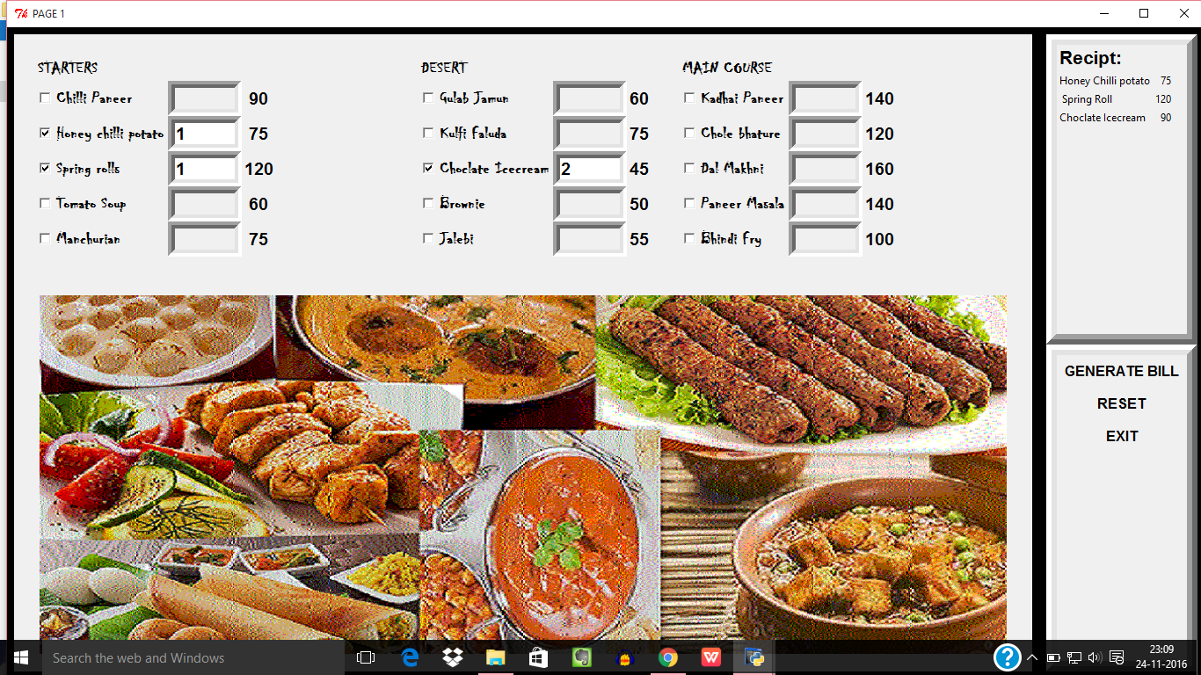

ONCE THE USER HAS GENERATED THE BILL, HE/SHE CAN MOVE FURTHER TO PAY THE BILL. THE 'PRINT' BILL BUTTON WILL TAKE THE USER TO ANOTHER SCREEN WHICH WILL DISPLAY THE BILL.

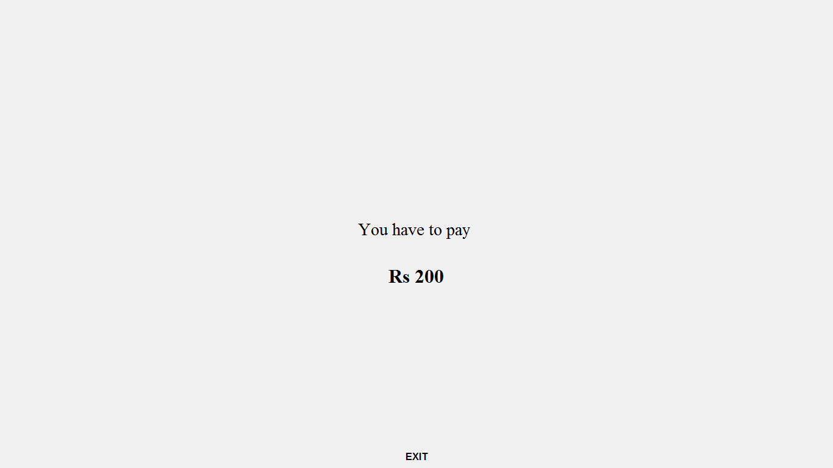

AFTER THAT THE USER CAN EXIT THE MENU BY PRESSING THE EXIT' BUTTON.

